**Project Design Phase**

**Problem – Solution Fit Template**

|  |  |
| --- | --- |
| Date | 27 June 2025 |
| Team ID | LTVIP2025TMID20380 |
| Project Name | HouseHunt:Finding Your perferct Rental Home |
| Maximum Marks | 2 Marks |

**Problem–Solution Fit Template – HouseHunt Problem Identified**

Many renters and property owners in semi-urban and urban areas struggle to connect reliably. Existing platforms are either too complex, unaffordable, or lack role-based access and verification features.

**Proposed Solution**

Our solution is HouseHunt, a web platform that connects property owners and renters with clear role-based access (user, owner, admin), property listing with image uploads, booking management, and owner approval features—all in one place.

**Purpose Alignment**

The purpose of HouseHunt is to provide a simple, secure, and transparent way for users to find and book properties and for owners to manage their listings, while admins ensure platform reliability and trust.

**Template:**

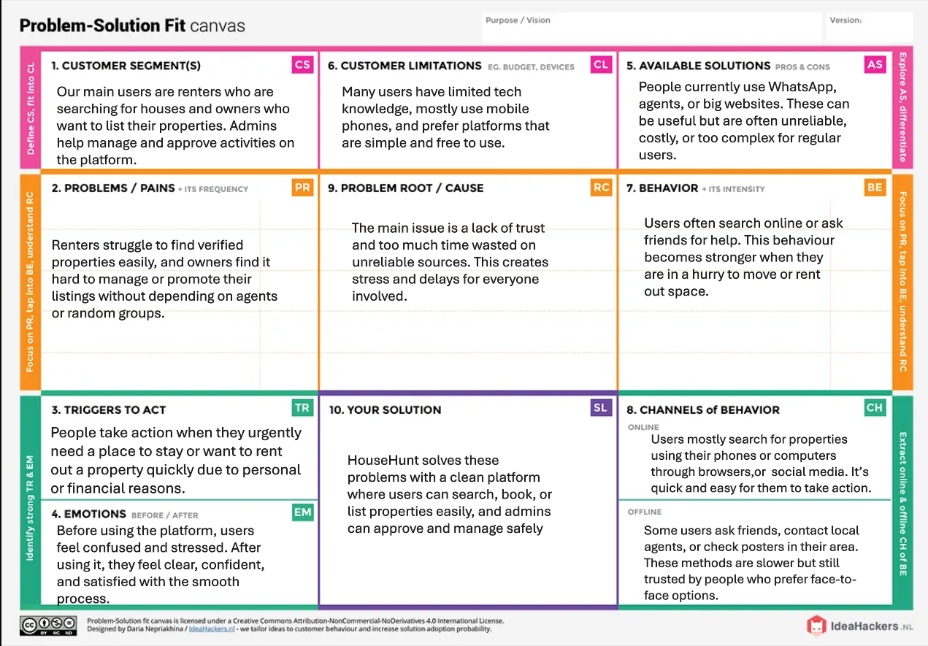

1. **WHO IS YOUR CUSTOMER?**

* Renters (looking for property)
* Property Owners (listing their properties)
* Admin (approving & managing platform)

1. **EXPLORE LIMITATIONS TO BUY/USE YOUR PRODUCT OR SERVICE**
   * Requires internet access
   * Desktop-optimized (mobile experience can be improved)
   * No direct payment gateway or live support yet
2. **HOW ARE YOU GOING TO BE DIFFERENT THAN COMPETITION?**

* Role-based dashboards (User, Owner, Admin)
* Booking feature + owner approval logic
* Clean, responsive UI with search and filter

1. **FOCUS ON FREQUENT, COSTLY, OR URGENT PROBLEM TO SOLVE**

HouseHunt solves the urgent problem of unverified listings, limited contact options, and disconnected rental systems.

1. **UNDERSTAND THE CAUSE OF THE PROBLEM**

* Lack of integrated platforms where both renters and owners can interact securely
* Traditional rental systems are time-consuming and scattered

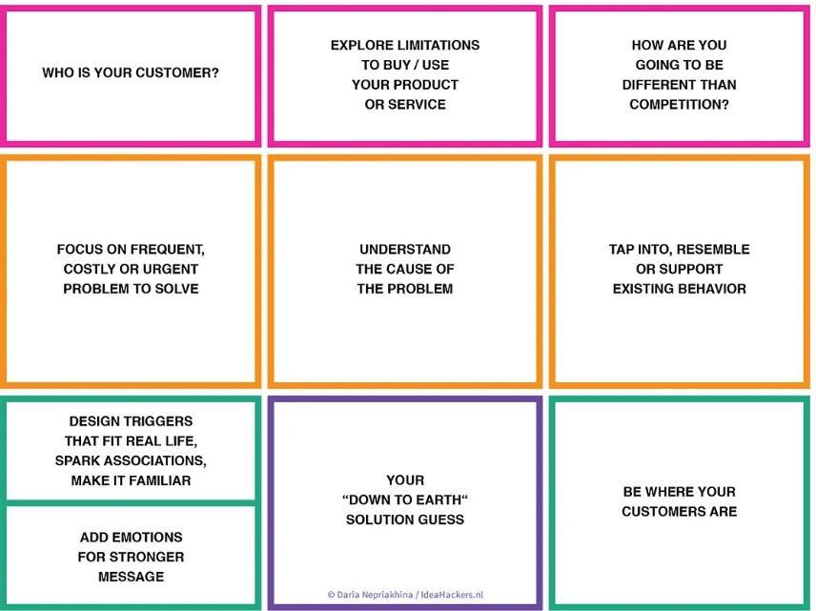

1. **TAP INTO, RESEMBLE, OR SUPPORT EXISTING BEHAVIOR**

* People are already used to searching for rentals online.
* We follow the same pattern — search, view, book — to make it easy and familiar.

1. **DESIGN TRIGGERS THAT FIT REAL LIFE, SPARK ASSOCIATIONS, MAKE IT FAMILIAR**

* Our platform looks and works like everyday apps people already use.
* We use simple buttons, clear labels, and smooth flow that feels comfortable.

1. **ADD EMOTIONS FOR STRONGER MESSAGE**

* The platform name HouseHunt evokes the excitement and struggle of finding a home
* Clean UI design brings comfort, trust, and a sense of modern reliability

1. **YOUR "DOWN TO EARTH" SOLUTION GUESS**

* We are not building a big complex platform.
* We just want to help users find and book properties easily, and let owners manage them simply.
* Our system is small, clean, and works well for basic rental needs.

1. **BE WHERE YOUR CUSTOMERS ARE**

Our platform works on browsers — both mobile and desktop.

It helps renters and owners who already use phones or laptops to go online and search for homes

**References**

1. IdeaHackers – Problem-Solution Fit Canvas

 <https://www.ideahackers.network/problem-solution-fit-canvas/>

1. Medium by Epicantus – Problem-Solution Fit Canvas [https://medium.com/@epicantus/problem-solution-fit-canvas-aa3dd59cb4fe](https://medium.com/%40epicantus/problem-solution-fit-canvas-aa3dd59cb4fe)